**Creating an AWS (GovCloud) Support Case**

VA has an ***Enterprise*** Support plan with AWS.

To open a support case for AWS GovCloud issues requires users to do so from within the corresponding AWS Commercial Account.

**Prerequisites:**

* AWS GovCloud Account ID number and corresponding AWS Commercial Account ID number
* Access to the corresponding AWS Commercial Account console
* Permissions within the corresponding AWS Commercial Account console to submit support cases

**All of the following information can be helpful to AWS Support engineers attempting to diagnose the issue:**

* A description of your use case. What is the intended behavior for this resource / application / project?
* The environment in which you’re observing the issue. Is this your production, staging, development, or test environment? Who is the intended audience for this content / application?
* Resource IDs of the affected resources. Include EC2 instance IDs, S3 object and bucket names, CloudFront distribution IDs, API request IDs, etc.
* Dates / times when you experienced the issue, and how long the issue persisted. Make sure to include your time zone.
* Log files from the approximate time the issue occurred. You can attach these directly to your case.
* Any error messages you’re receiving.
* The steps you took, or the steps a Support engineer might take, to reproduce the issue.
* For networking and DNS issues, the outputs of traceroute / mtr / telnet / netcat / dig / nslookup commands.

To open a new case, sign in to the [Support Center](https://console.aws.amazon.com/support/home#/) with your commercial AWS account user credentials. If you are opening a case for your AWS GovCloud (US) account, ***include a note that this case is for your AWS GovCloud (US) account, and include your AWS GovCloud (US) account ID.*** Do not enter any ITAR-regulated data in the case.

If not taken directly to the Support Center, click on Support in the upper-right corner, then select Support Center as shown below:

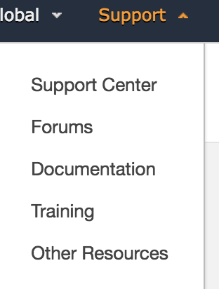

Click **Create case** as shown below: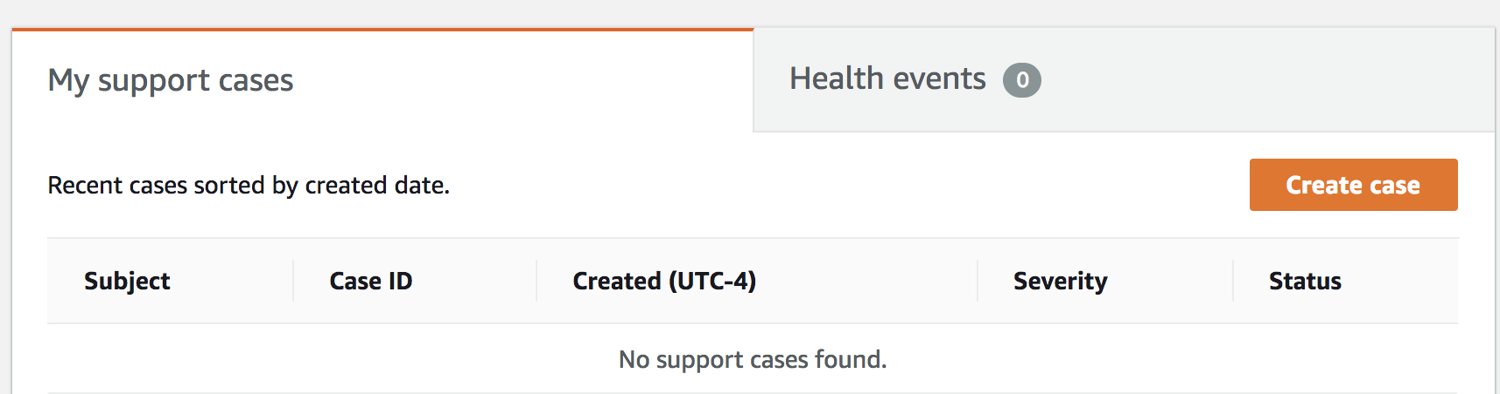

There are three types of cases you can open:

* **Account and Billing Support** cases are available to all AWS customers. This case type connects you to customer service for help with billing and account-related questions.
* **Service Limit Increase** requests are also available to all AWS customers. For information on the default service limits, see [AWS Service Limits](http://docs.aws.amazon.com/general/latest/gr/aws_service_limits.html).
* **Technical Support** cases connect you to technical support for help with service-related technical issues and, in some cases, third-party applications. If you have a Developer support plan, you can communicate via the web. If you have a Business or Enterprise support plan, you can also communicate by phone or live chat.

### **VA Example: Creating a Case**

Here is an example of a Technical Support case (shown in two parts for readability). The lists that follow the form example explain some of your options and best practices.

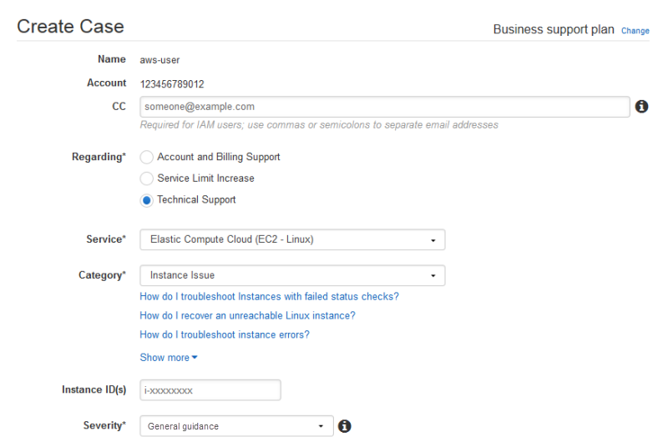

* **Contact Information**. In the **CC** box, enter the email addresses of people to be notified when the status of the case changes. If you are signed in as an IAM user, include your own email address. If you are signed in with your email address and password, you don't need to include your email address in the **CC** box.
  + VA to CC AWS for added visibility:
    - [jhjennis@amazon.com](mailto:jhjennis@amazon.com), [sarnwine@amazon.com](mailto:sarnwine@amazon.com), [chrisanj@amazon.com](mailto:chrisanj@amazon.com), [ericgri@amazon.com](mailto:ericgri@amazon.com), [syahmad@amazon.com](mailto:syahmad@amazon.com)
* **Regarding**. Select the type of case you want to create. In this example, we select **Technical Support**.
* **Service**. If your question affects multiple services, choose the service that is most applicable. In this case, we select **Elastic Compute Cloud (EC2 - Linux)**.
* **Category**. Choose the most appropriate category. In this case, we’re having trouble connecting to an instance, so we choose **Instance Issue**. When you select a category, links to information that might help to resolve your problem appear below the **Category** selection.

Based on your category choice, contextual text boxes often prompt for additional information. In this case, we’re prompted to provide **Instance ID(s)**. In general, it’s a good idea to provide resource IDs even when not prompted.

* **Severity**. All customers with a paid support plan can choose **General guidance** (1-day response time) or **System impaired** (12-hour response time) severity. Customers with a Business support plan can also choose **Production system impaired** (4-hour response) or **Production system down** (1-hour response). Enterprise plan customers can also choose **Business-critical system down** (15-minute response). Note that response times are for first response from AWS Support, and do not apply to subsequent responses. For third-party issues, response times can be longer, depending on the availability of skilled personnel. For details, see *Choosing a Severity*.

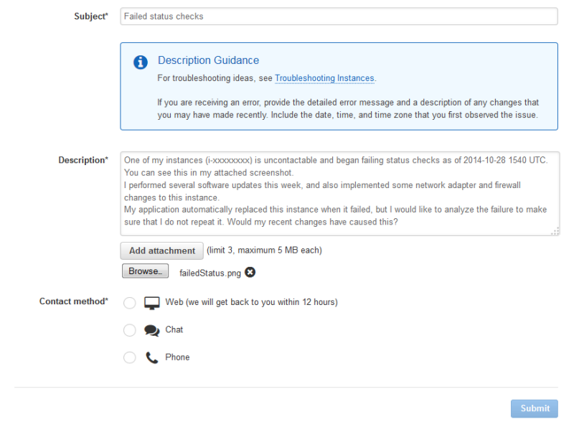

* **Subject**. Treat this like the subject of an email message and sum up your issue as briefly as possible. In this case, we use the subject "Failed status checks."
* **Description**. This is the most important information that you provide to Support. For most service and category combinations, a prompt suggests information that is most helpful for the fastest resolution. For more guidance, see *Describing Your Problem*.
* **Attachments**. Screen shots and other attachments (less than 5 MB each) are often helpful. In this case, we’ve added one to show the failed status check.
* **Contact method**. Select a contact method. The options vary depending on the type of case and your support plan. If you choose **Web**, you can read and respond to the case progress via Support Center. If you have a Business or Enterprise support plan, you can also select **Chat** or **Phone**. If you select **Phone**, you are prompted for a callback number.
* **Submit**. Click the **Submit** button when your information is complete and you're ready to create the case.

#### Choosing a Severity

It might be tempting to open cases at the highest severity allowed by your support plan. However, we strongly encourage limiting the use of the highest severities to cases that cannot be worked around or that directly affect production applications. Plan ahead to avoid needing high-severity cases for general guidance questions.

Here is a summary of severity levels, response times, and example problems.

**Note**: We make every reasonable effort to respond to your initial request within the indicated timeframe.

|  |  |  |
| --- | --- | --- |
| **Severity** | **First-Response Time** | **Description / Support Plan** |
| **General guidance** | 24 hours | You have a general development question, or you want to request a feature. (Developer*, Business, and Enterprise support plans) |
| **System impaired** | 12 hours | Non-critical functions of your application are behaving abnormally, or you have a time-sensitive development question. (Developer*, Business, and Enterprise support plans) |
| **Production system impaired** | 4 hours | Important functions of your application are impaired or degraded. (Business and Enterprise support plans) |
| **Production system down** | 1 hour | Your business is significantly impacted. Important functions of your application are unavailable. (Business and Enterprise support plans) |
| **Business-critical system down** | 15 minutes | Your business is at risk. Critical functions of your application are unavailable. (Enterprise support plan) |

#### Describing Your Problem

Your description should be as detailed as possible and include relevant resource information, along with anything else that would be beneficial, depending on the case. For example, to troubleshoot performance, include time stamps and logs. For feature requests or general guidance questions, include a description of your environment and purpose. In all cases, follow the **Description Guidance** that appears on your case submission form.

When you provide as much detail as possible, you increase the chances that your case will be resolved quickly.

### Monitoring and Maintaining Your Case

You can monitor the status of your case in Support Center. A new case begins in the "Unassigned" state. When an engineer begins work on a case, the status changes to "Work in Progress." The engineer responds to your case, either to ask for more information ("Pending Customer Action") or to let you know that the case is being investigated ("Pending Amazon Action").

Whenever your case is updated, you receive email with the correspondence and a link to the case in Support Center—you cannot respond to case correspondence via email. When you are satisfied with the response or your problem has been solved, you can select **Close Case** in Support Center. If you do not respond within six days, the case is closed automatically. You can always reopen a resolved or closed case.

It is important to create a new case for a new issue or question. If case correspondence strays from the original question or issue, a support engineer might ask you to open a new case. When opening cases related to old inquiries, it is helpful to include the related case number so that we can refer to previous correspondence.

### Case History

Case history information is available for 12 months after creation.

**Customer Support Differences for the AWS GovCloud (US) Region**

* The Customer Support Center is available only through the commercial AWS account that is associated with your AWS GovCloud (US) account.
* The Service Health Dashboard for the AWS GovCloud (US) Region can be found at <http://status.aws.amazon.com/govcloud>.
* AWS accounts with an associated AWS GovCloud (US) account are prohibited from uploading attachments in Support Center.

## Features of AWS Support Plans

All AWS customers automatically have around-the-clock access to these features of the Basic support plan:

* Customer Service: one-on-one responses to account and billing questions
* Support forums
* Service health checks
* Documentation, whitepapers, and best-practice guides

Customers with a Developer support plan have access to these additional features:

* Best-practice guidance
* Client-side diagnostic tools
* Building-block architecture support: guidance on how to use AWS products, features, and services together

In addition, customers with a Business or Enterprise support plan have access to these features:

* Use-case guidance: what AWS products, features, and services to use to best support your specific needs
* [AWS Identity and Access Management](https://docs.aws.amazon.com/awssupport/latest/user/getting-started.html#iam) (IAM) for controlling individuals' access to AWS Support
* [AWS Trusted Advisor](https://docs.aws.amazon.com/awssupport/latest/user/getting-started.html#trusted-advisor), which inspects customer environments and identifies opportunities to save money, close security gaps, and improve system reliability and performance
* An API for interacting with Support Center and Trusted Advisor, allowing for automated support case management and Trusted Advisor operations
* Third-party software support: help with Amazon Elastic Compute Cloud (EC2) instance operating systems and configuration and performance of the most popular third-party software components on AWS

In addition, customers with an **Enterprise** support plan have access to these features:

* Application architecture guidance: consultative partnership supporting specific use cases and applications
* Infrastructure event management: short-term engagement with AWS Support to get a deep understanding of your use case and provide architectural and scaling guidance for an event
* AWS Concierge
* Technical account manager
* White-glove case routing
* Management business reviews

**Additional Resources**

* Getting Started - <https://docs.aws.amazon.com/awssupport/latest/user/getting-started.html>
* Support FAQs - <https://aws.amazon.com/premiumsupport/faqs/>